Software Requirements Specification Template

Software Engineering

<Turbo Turtle>

Software Requirements Specification

<Version One>

<Date>

<Ruba Al-Saedi

Ghala abed

Lama Salawati

Retaj mujahed>

Lead Software Engineer

Prepared for

Foundation of Software Engineering Course

**Table of Contents**

Revision History

Document Approval

1. Introduction 5

1.1 Purpose ……………………………………………………………………………………………….. 5

1.2 Scope ………………………………………………………………………………………………….. 5

2. General Description 6

2.1 Product Perspective……………………………………………………………………………… 6

2.2 Product Functions……………………………………………………………………………….. 6

2.3 User Characteristics……………………………………………………………………………… 7

2.4 General Constraints ……………………………………………………………………………… 7

2.5 Assumptions and Dependencies …………………………………………………………………… 8

3. Specific Requirements

3.1 External Interface Requirements………………………………………………………………. 9

3.1.1 User Interfaces 9

3.1.2 Hardware Interfaces 10

3.1.3 Software Interfaces 10

3.1.4 Communications Interfaces 10

**3.2 Functional Requirement………………………………………………………………...** 11

3.2.1 Registration ………………………………………………………………………….…….11

3.2.2 Displaying ………………………………………………………………………………..11

3.2.3 Searching …………………………………… ……………………………………………12

3.2.4 Order - reorder …………………………………………………………………………….12

3.2.5 payment ……………………………………………………………………………………13

3.2.6 Contact …………………………………………………………………………………….13

3.2.7 Deliver ……………………………………………………………………………………14

3.2.8 Rating ……………………………………………………………………………………. 14

3.2.9 Customer service …………………………………………………………………………. 15

**3.3 Use Case ……………………………………………………………………………………….16**

3.3.1 Use Case #1 Registration…………………………………………………………………………..17

3.3.2 Use Case #2Displaying …………………………………………………………………………...18

*3.3.3 Use Case #3 Searching……………………………………………………………………………..19*

*3.3.4 Use Case #4 Order - reorder………………………………………………………………………20*

*3.3.5 Use Case #5 Contact ……………... ……………………………………………………………….21*

*3.3.6 Use Case #6 Rating …………….……………………………………………………………… …22*

*3.3.7 Use Case #7 payment……………………………………………………………………………….23*

*3.3.8 Use Case #8 Customer service ………...……………………………………………………… 24*

*3.3.9 Use Case #9 Delivery ………………………………………………………………………………..25*

3.4 Non-Functional Requirements 26

3.5.1 Performance 26

3.5.2 Reliability 26

3.5.3 Availability 26

3.5.4 Security 26

**LIST OF FIGURES**

Figure :A prototype of turbo turtle application............................................ 9

Figure 2: General Use Case .... ....................................................................16

Figure 3: Use Case #1 Registration......……………………………………… 17

Figure 4: Use Case #2 Displaying…………………………………………… .18

Figure 5: Use Case #3 Searching ........................................................................ 19

Figure 6: Use Case #4 order – reorder.................................................................. 20

Figure 7: Use Case #5 Contact ......................................................................... 21

Figure 8: Use Case #6 Rating ......................................................................... 22

Figure 9: Use Case #7 Payment ..........................................................................23

Figure 10: Use Case #8 Customer Service ..................................................... 24

Figure 11: Use Case #9 Deliver ...................................................................... 25

# LIST OF TABLES

Table 1: User Characteristics ...................................................................... 7

Table 2 : Registration ................................................................................ 17

Table 3 : Displaying ..................................................................................... 18

Table 4 : Searching ........................................................................................ 19

Table 5 : order – reorder................................................................................. 20

Table 6 : Contact ............................................................................................. 21

Table 7 : Rating ............................................................................................ 22

Table 8 : Payment........................................................................................... 23

Table 9 : Customer Service............................................................................ 24

Table 10 : Delivery............................................................................................ 25

# 1. Introduction

## *In an era where time is of the essence, and the love for diverse cuisines knows no bounds, our application is designed to redefine the way you experience and enjoy food. This Software Requirements Specification (SRS) document encapsulates the comprehensive features and functionalities that make our food delivery app a seamless and delightful solution for both users and restaurant partners. From intuitive user interfaces to robust backend systems, as we unveil the details of our cutting-edge food delivery application*.

## 1.1 Purpose

*Deliver the purpose of this document to describe ( Turbo Turtle ) application that manage deliveries for* *customers to ease the delivery services.*

## 1.2 Scope

*1 -* *Convenience and ease of use :*

*Users can easily and quickly order food from a wide range of restaurants available in their area through the app. This saves them time and effort in searching for a place to eat and traveling to it.*

*2 - Easy and secure payment :*

*Users can easily and securely pay the bill through the app, whether it's through electronic payment or using credit cards or online banking services.*

*3 - Boosting restaurant businesses:*

*Restaurant owners can benefit from delivery apps to increase their customers and sales. Small and medium-sized restaurants can reach a wider customer base and provide delivery service without the need for their own infrastructure.*

*4 - . Availability across different operating systems:*

*The app is available for download on various operating systems, allowing users to access it regardless of their device type.*

***2.* GeneralDescription**

***2.1 Product Perspective***

*Turbo Turtle app is redefining food delivery in a fast-paced world. With a seamless user experience that is both easy to use and efficient, Turbo Turtle ensures that orders are delivered quickly and accurately, even during peak times. The app also caters to diverse culinary preferences, with a wide variety of restaurants and cuisines to choose from.*

## 2.2 Product Functions

## *1-system user will be able to save their personal data securely to the system*

## *2-System user will be able to search and choose specific restaurants*

## *3-system user will be able to display the previous order or reorder the item.*

## *4-system user will be able to rate the restaurants*

## *5-system user will be able to contact the customer service*

## *6-system user will be able to contact the delivery man*

## *7-System user will be able register using their email address or phone number.*

## *8-system user will be able to save multiple payment methods for future use and easily select the desired one during checkout.*

*9-system user will be able to rate the delivery man.*

## 

## 2.3 User Characteristics

|  |  |
| --- | --- |
| User | Description |
| customer | *Someone who use the app for mobile delivering services.* |
| Delivery man | *Someone who's responsible for delivering the food.* |
| administrator | *Someone who manages all customer's needs and produce needed dashboards* |

## 2.4 General Constraints

* *Service Area Inclusivity: Take into account the extent of the delivery service coverage and accommodating various locations and potentially different countries.*
* *Network Reliability: The software is limited by the necessity of a reliable shared internet connection.*
* *Database Capacity: Additionally, the software is constrained by the database capacity, necessitating a substantial amount of available free space.*

**2.5 Assumptions and Dependencies**

*1- Application must work on different browsers (Chrome, Firefox, IE, Edge & Safari).*

*2- Application must work on different smart devices, example: iOS or Android.*

*3 - Web application must be responsive on all devices.*

*4 - Customer journey for open an account to take up to 5 minutes.*

*5 - System must support Arabic and English languages.*

*6 -Accurate location information for user is essential for successful delivery.*

*7 - Internet connection is required to use this application.*

# 

### 

### 3.1 External Interface Requirements

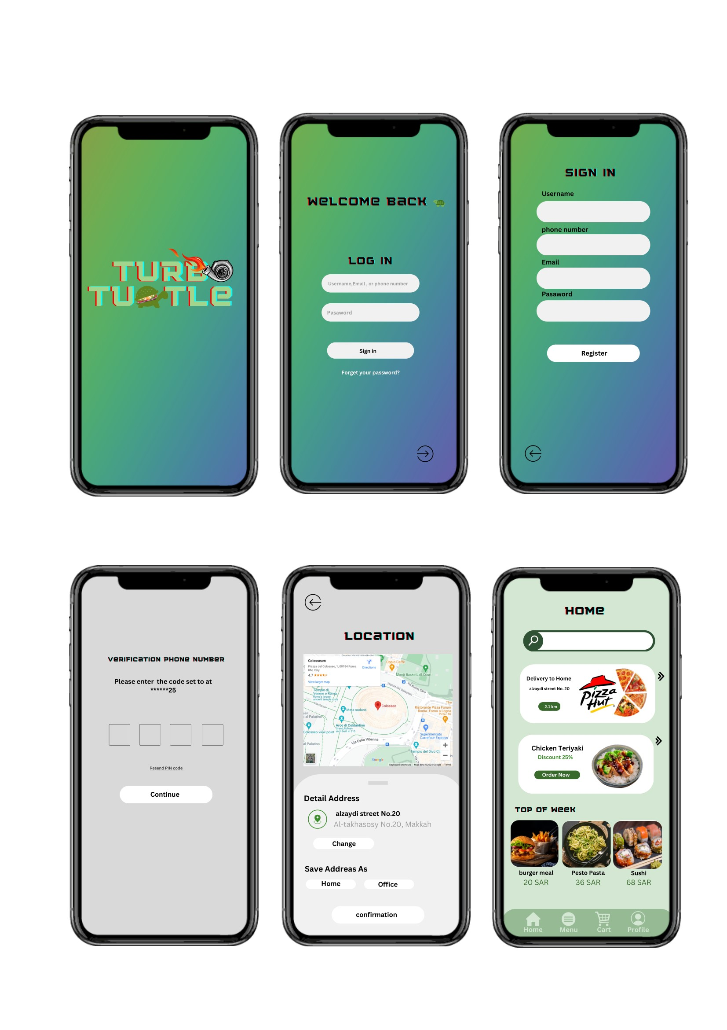

Figure 1 A prototype of turbo turtle application

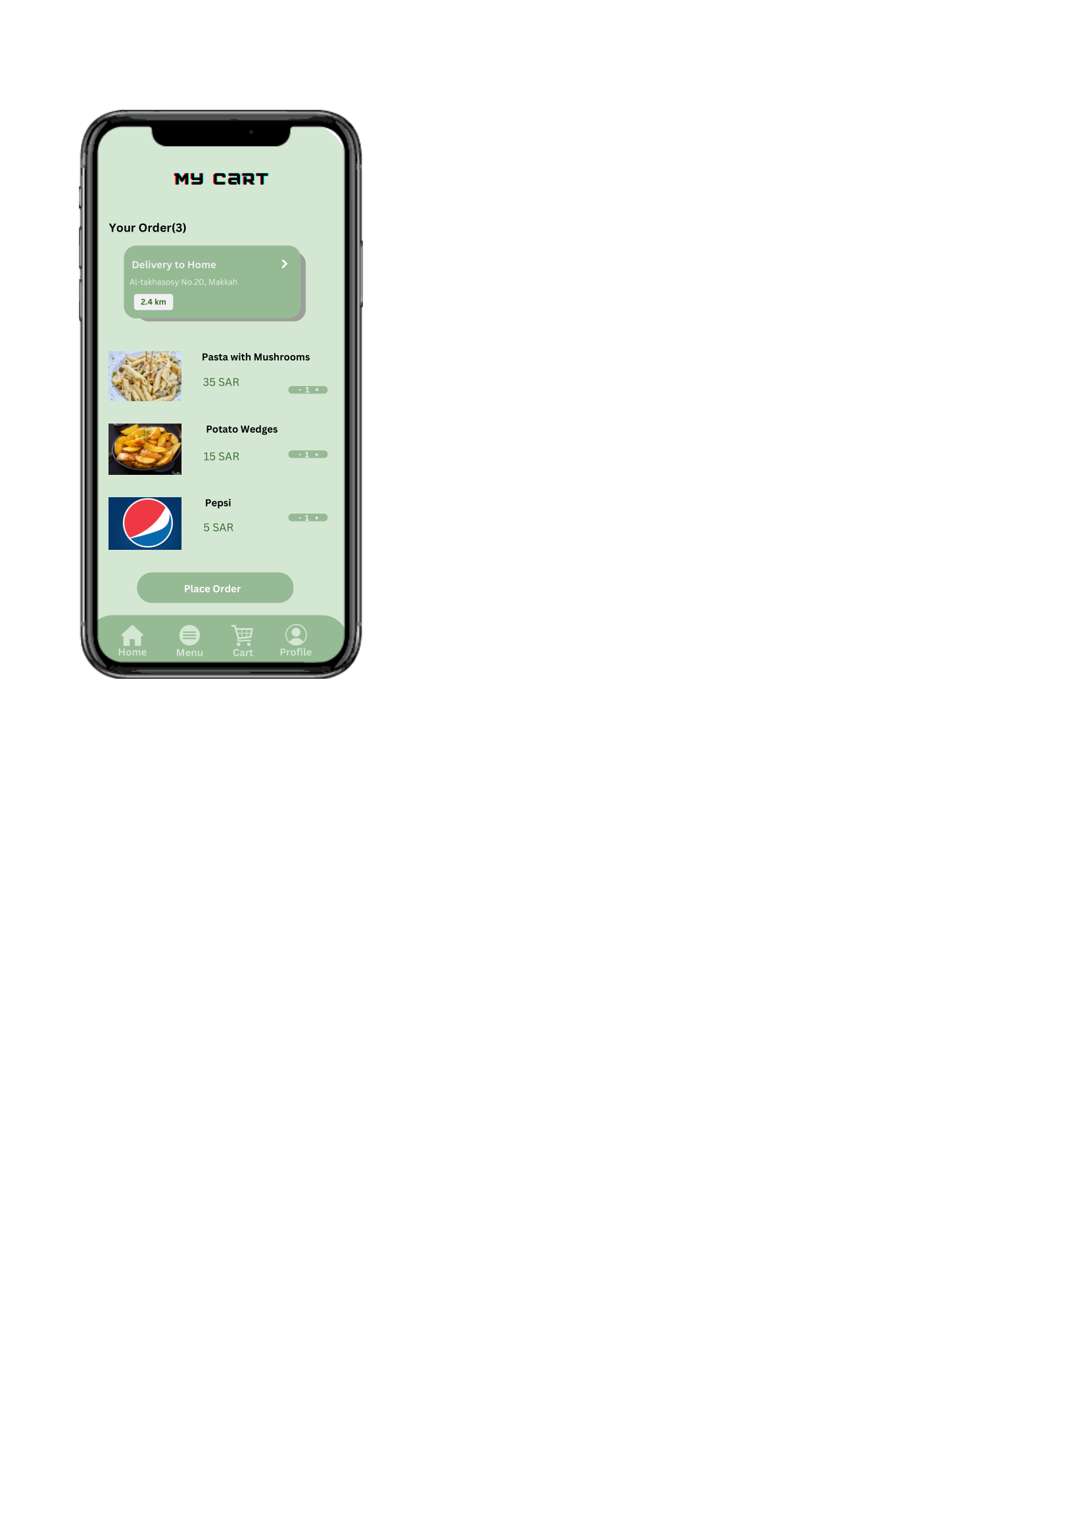

### Interfaces

### *3.1.2 Hardeare Interface*

### *The web application aims to be compatible with a variety of browsers such as Chrome, Firefox, Internet Explorer, Edge, and Safari. This requires ensuring that the application meets the requirements and standards of each of these browsers, thereby providing a consistent and compatible user experience.*

### *Furthermore, the application should be able to run on a range of smart devices, such as iOS and Android devices*.

### 3.1.3 Software Interfaces

### -*A database :to store data about restaurants, menus, orders, and users.*

### *- A web server : to handle requests from users.*

### *- Location-based services : are essential for food delivery apps. They help to identify the location of restaurants and customers, which is used to provide accurate delivery estimates, track the progress of orders, and improve the user experience*.

### 3.1.4 Communications Interfaces

The system will use the WIFI.

### 3.2 Functional Requirements

**3.2.1. Registration**

Introduction:   
The most important action performed at a Turbo Turtle is the user registration.   
  
Inputs:  
 Phone number or email address, username, password, verification code.

Description:  
 The user shall be able to Registration to be able to access turbo turtle app feature.

* The access shall be allowed if and only if:
* The email address or phone number should be an actual email address and phone number that you use and have access to.
* The password should be at least 10 characters.

Outputs:   
- Upon successful registration, the system shall generate a unique user identifier.

- The system shall store the user's information, including username, email address, and additional details, in the user database.

**3.2.2 Displaying**

Introduction: The Turbo Turtle app should provide a user-friendly interface for displaying relevant information to the users.

Inputs:

- User-specified restaurant or preferred food type.

- User preferences or filtering factors (such as price range, ratings).

Description:

The display feature in Turbo Turtle is responsible for presenting restaurant-related information to users in a user-friendly manner.

Outputs:

- The system should present restaurant details in a readable and understandable format for the user.

- Users can view the menu, prices, descriptions, and any available promotions or discounts.

- The system should display customer ratings and reviews to assist users in making informed decisions based on their needs.

**3.2.3 Searching**Introduction:   
The searching feature in Turbo Turtle enables users to easily discover and find restaurants, and relevant information. It aims to provide a seamless and efficient search experience.   
  
Input:   
The system includes a prominent search bar accessible from the main interface. Users can input search queries, including restaurant names, cuisine types.  
   
Description:   
Users interact with the search feature by providing input through the app's interface.  
  
Outputs:  
 The system shall display a list of restaurants matching the search criteria, including relevant details such as names, cuisines, ratings, and delivery times.

**3.2.4 Order-reorder**   
  
Introduction:   
The Order-Reorder feature enhances user convenience by allowing them to easily replicate previous orders. It streamlines the reordering process for favorite meals, promoting a seamless and efficient user experience.  
  
 Input:  
 -Users initiate the reorder process by navigating to their order history.  
 -Users can select a specific past order that they wish to reorder.   
  
Description: The Order-Reorder feature enables users to effortlessly recreate a previous order, reducing the time and effort required for placing recurring requests.  
  
 Outputs:  
 -Users receive a confirmation message indicating the successful placement of the reorder.  
 -The app displays the replicated order details, including items, quantities, and total cost.

**3.2.5 payment**  
  
Introduction:   
The payment feature is a crucial component of the food delivery app, facilitating secure and convenient transactions. It allows users to seamlessly pay for their orders, providing a hassle-free experience.   
  
Input:   
-Users initiate the payment process by selecting the desired payment method from available options.  
 -Users enter necessary payment details, including credit card information.   
  
Description: The payment process involves a series of steps, ensuring that users can securely complete transactions for their food orders.   
  
Outputs: Users receive a confirmation message indicating the successful completion of the payment transaction.  
 In case of any payment issues, users are notified with clear error messages and instructions.

**3.2.6 Contact**

Introduction: The Turbo Turtle application should facilitate communication between users and relevant parties

Inputs: User's request for assistance or communication

Description: The application should provide the following contact options:

Customer Service: Users should be able to access customer service representatives for inquiries, complaints, or assistance related to orders, payments, or application functionalities.

- Delivery Courier: Users should be able to communicate with the assigned delivery person to track orders, provide delivery instructions, or address any urgent matters related to delivery.

Outputs:

- User queries, requests, and messages are forwarded to the appropriate parties.

- Responses, assistance, and information from the connected parties are conveyed to the users.

**3.2.7 Deliver**

Introduction:   
providing a platform for users to browse, select, and order food from various restaurants, facilitating convenient and efficient food delivery services.  
  
 Input:  
- Capture details such as name, contact information, and address for user account creation.   
-Define the information required when placing an order, such as selected items, quantity, and special instructions.

Description:   
Describe how users can track the status of their orders and receive notifications about estimated delivery times.

Output:   
- Detail how users receive confirmation of their orders, including order summaries and estimated delivery times.  
- Specify how users can access and download invoices or receipts for their orders.

***3.2.8 Rating***

Introduction:  
 The Rating feature within the Food Delivery App aims to enhance user experience by allowing customers to provide feedback on delivered products and services.  
  
 Input: -  
 Users should be able to rate the overall delivery experience, food quality, and delivery time on a scale or through qualitative feedback.   
- Allow users to submit ratings for specific items ordered or the entire order.  
- Set character limits for review comments to ensure concise and relevant feedback.

Description: The Rating feature is all about collecting, presenting, and managing customers feedback. It's a tool for you to express your feelings and for us to understand how we can make things better.  
  
Output:   
- Customer reviews and comments should be prominently displayed, providing insights into user opinions.   
-Administrators gain access to comprehensive performance metrics derived from user ratings, offering valuable data for evaluating and refining products, services, or the entire platform.

**3.2.9 Customer service**   
 Introduction:   
The Customer Service module is designed to enhance user satisfaction and promptly resolve queries, contributing to an overall positive user experience.  
  
 Input: - The system shall accept user inquiries submitted through various channels, including in-app chat, email, and phone.   
- Customer service representatives shall have access to user details, including order history and preferences.  
  
 Description:  
 The system shall log and timestamp all incoming user inquiries, capturing relevant details such as user ID, date, and query content and the system shall support the escalation of complex issues to higher-level support or specialized departments.   
  
Output:   
- The system is required to generate timely and accurate responses to customer inquiries.

- Responses should be provided through the same channel used for the inquiry, maintaining consistency.

## 

## 3.3 Use Cases

*turbo Turtle*

*Figure 2 A General Use Case*

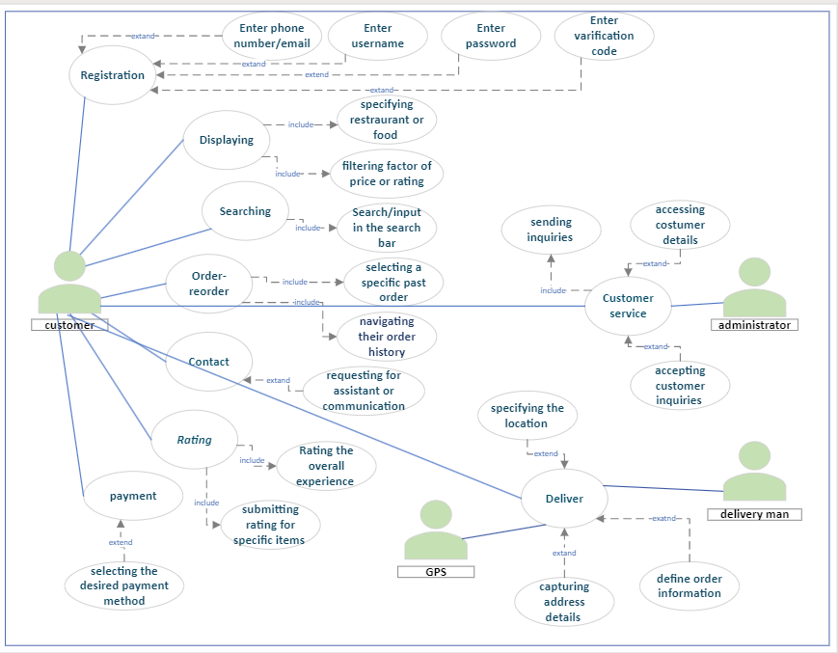

### 

### 3.3.1 Use Case #1

*Table 1 Use Case 1 Registration*

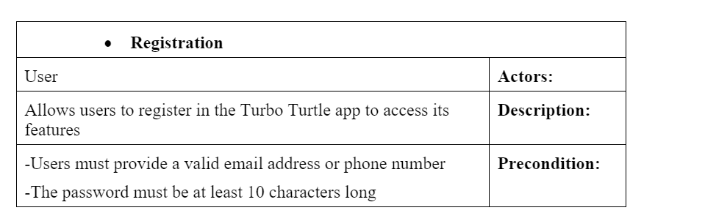

*Figure 3 Registration*

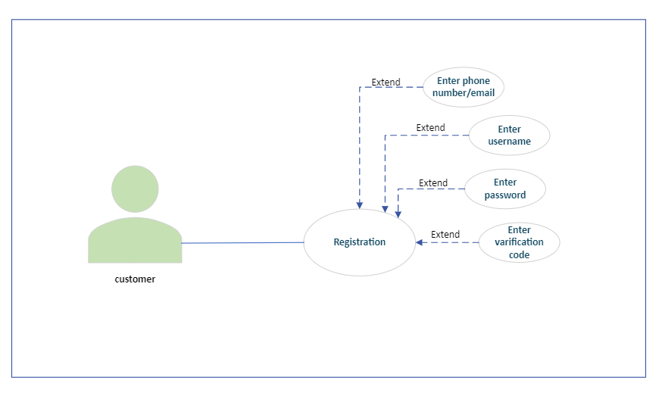

### 

### 3.3.2 Use Case #2

### 

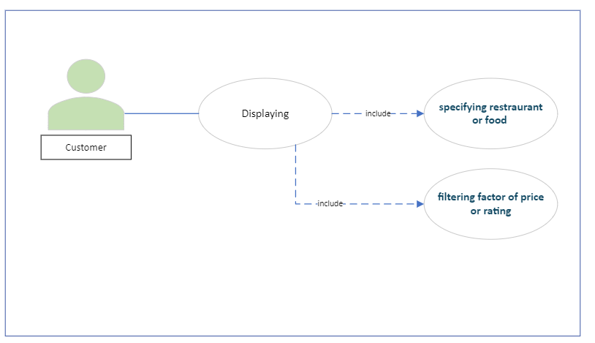

*Table 2 Use Case 2 Displaying*

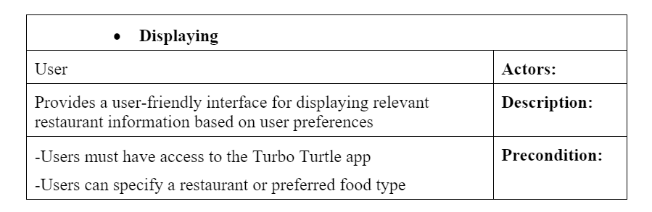

*Figure 4 Displaying*

### 

### 3.3.3 Use Case #3

*Table 3 use case 3 Searching*

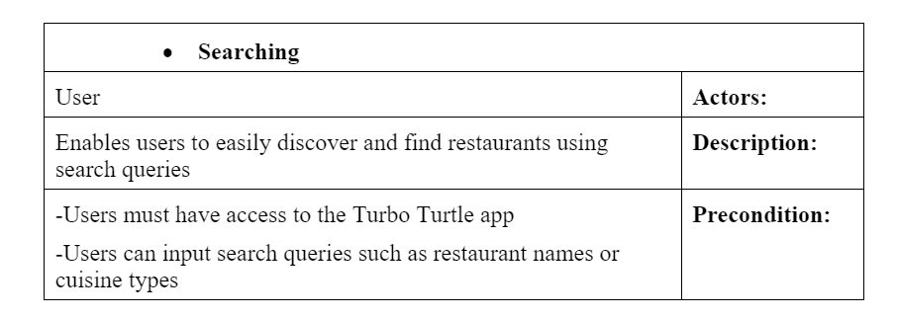

*Figure 5 Searching*

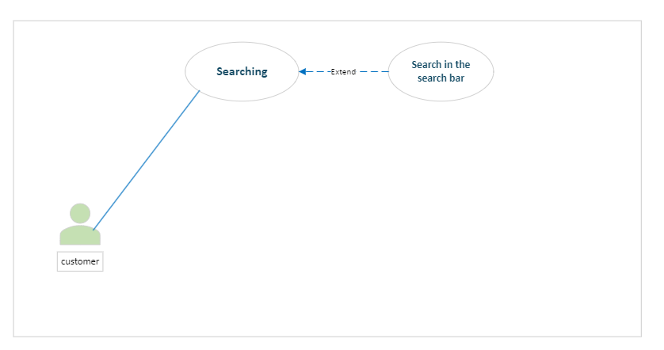

### 

### 3.3.4 Use Case #4

*Table 4 use case 4 Order - reorder*

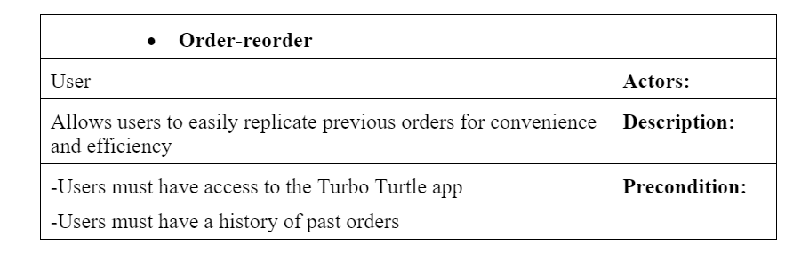

*Figure 6 order - reorder*

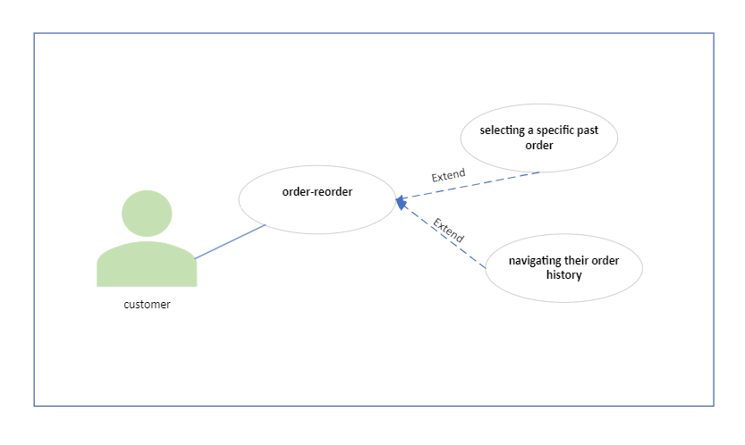

### 3.3.5 Use Case #5

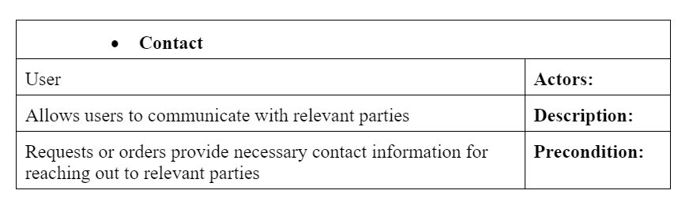

*Table 5 use case 5 contact*

*Figure 7 contact*

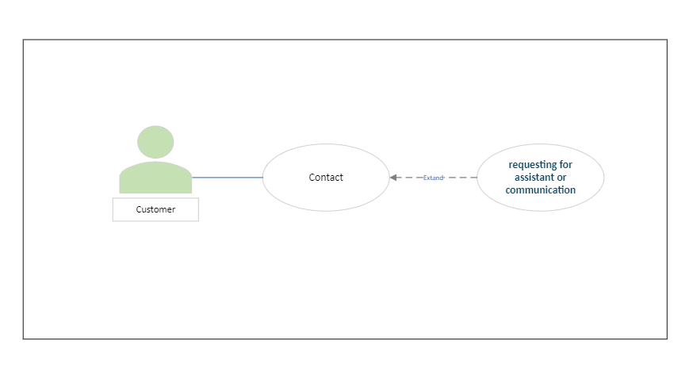

### 3.3.6 Use Case #6

### *Table 6 use case 6 Reting*

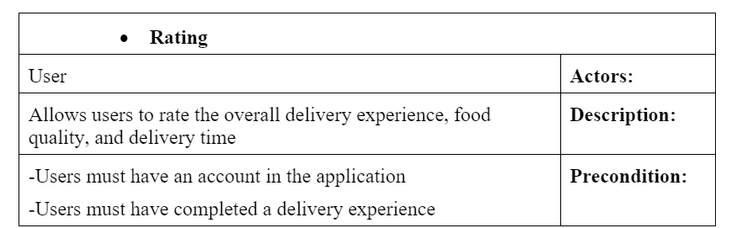

*Figure 8 Reting*

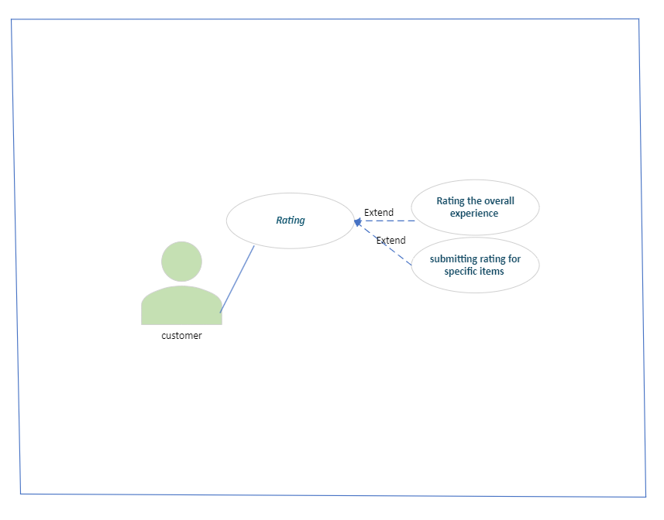

### 

### 3.3.7 Use Case #7

### *Table 7 use case 7 payment*

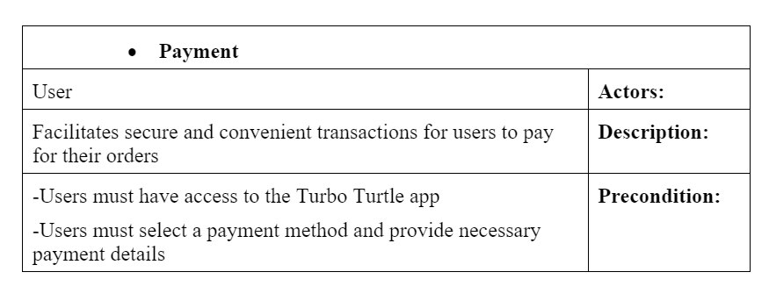

*Figure 9 payment*

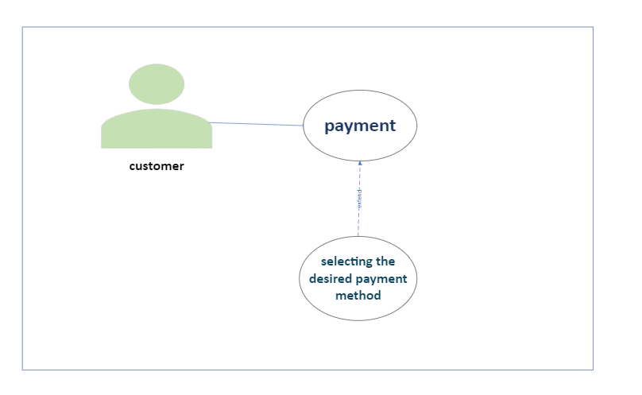

## 

## 3.3.8 Use Case #8

### *Table 8 use case 8 customer service*

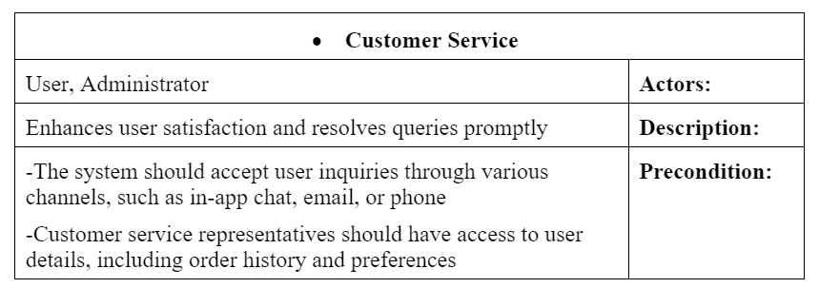

*Figure 10 Customer service*

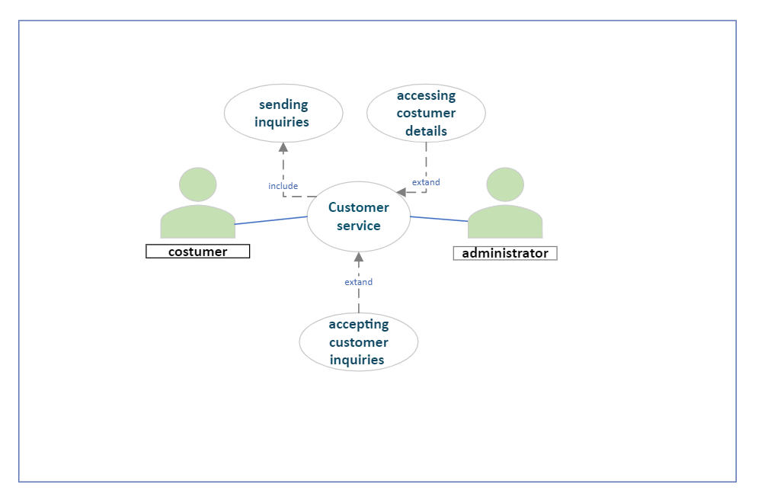

### 3.3.9 Use Case #9

### *Table 9 use case 9 delivery*

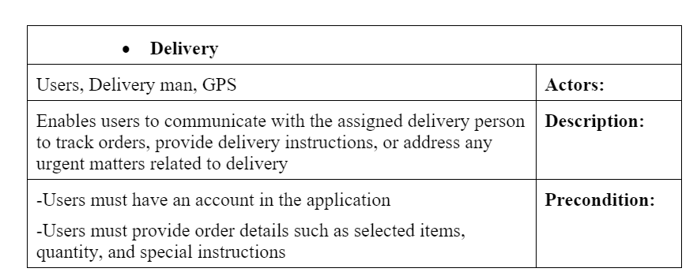

*Figure 11 delivery*

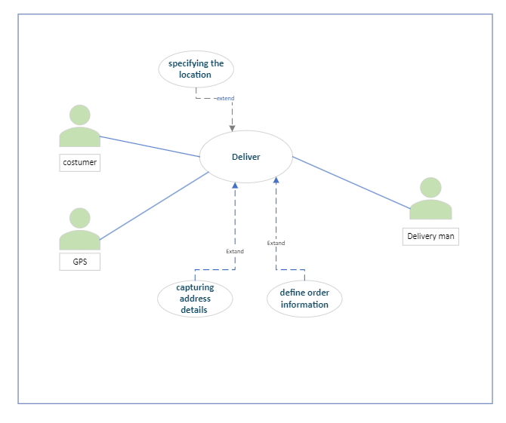

## 

## 3.5 Non-Functional Requirements

### *3.5.1 Performance Respone time: the system shall respond to user requests within 2 second for 98% of the transactions. Throughout: During peak usage times, the system should have the capacity to support a minimum of 1000 concurrent users without performance degradation.*

### 3.5.2 Reliability *Fault tolerance : The system must be able to recover from failures without compromising data integrity. Backup and Recovery: data backup shall performed daily, and data recovery should take no longer then 2 hours in case of failure.* 3.5.3 Availability *Availability : the system should hava at least 100% uptime per year , allowing for schedules*

### *maintencance.*

### 3.5.4 Security *Data encryption: All sensitive user data , including password And payment information must be encrypted using industry - standard encryption algorithm. Access controls: The system shall implement role-based access control (RBAC) to restrict access to authorized personnel only.*